方嘉祥 F74056166

(1)

I use Riemann Sums to solve solve numerical integration

I use secant method and bisection method to find the roots

(2) type the equation into it and the program will use Riemann Sums to get answer

Prob1

(i)2.156515647

(ii)0.010422761

i also use Trapezoid Method to check

Prob2

A total of 10000000 random points are used; the volume of the ellipsoid is 25.1340576000

Prob3

(1) The total flux is 113109806156.41168000 (Volt.m)

(2) The total flux is 113109806156.41168000 (Volt.m)

(3) The total flux is 113110310906.44418000 (Volt.m)

(4) The total flux is 9328448716.55447390 (Volt.m)

Prob4

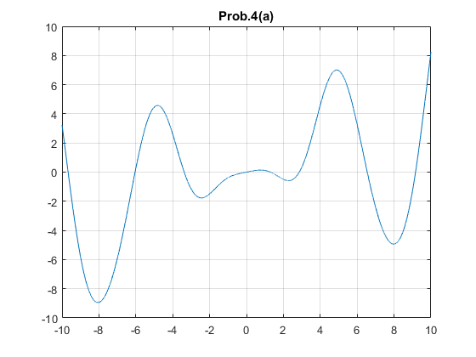

The smallest positive root of Prob.4(a) is 1.301498004

The largest negative root of Prob.4(a) is -3.377591420

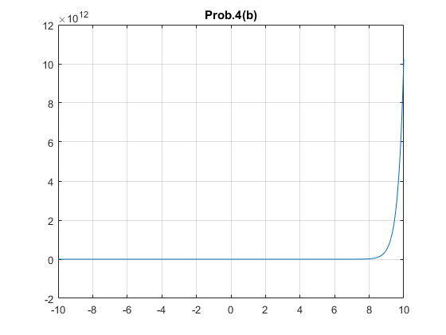

The smallest positive root of Prob.4(b) is 0.910012246

The largest negative root of Prob.4(b) is -0.458961199

Prob5

set sun(0,0)

L1 = (RMsMe(1-(Me/3(Ms+Me))^(1/3)),0)

L2 = (RMsMe(1+(Me/3(Ms+Me))^(1/3)),0)

L2 = (-RMsMe(1+(5\*Me)/12(Ms+Me)),0)

The distance ratio of L1:0.989997

The distance ratio of L2:1.010003

The distance ratio of L3:1.000001